# Docker Assignment-4

# Create a Dockerfile with the following specs:

## Ubuntu container

## Apache2 installed

## Apache2 should automatically run once the container starts

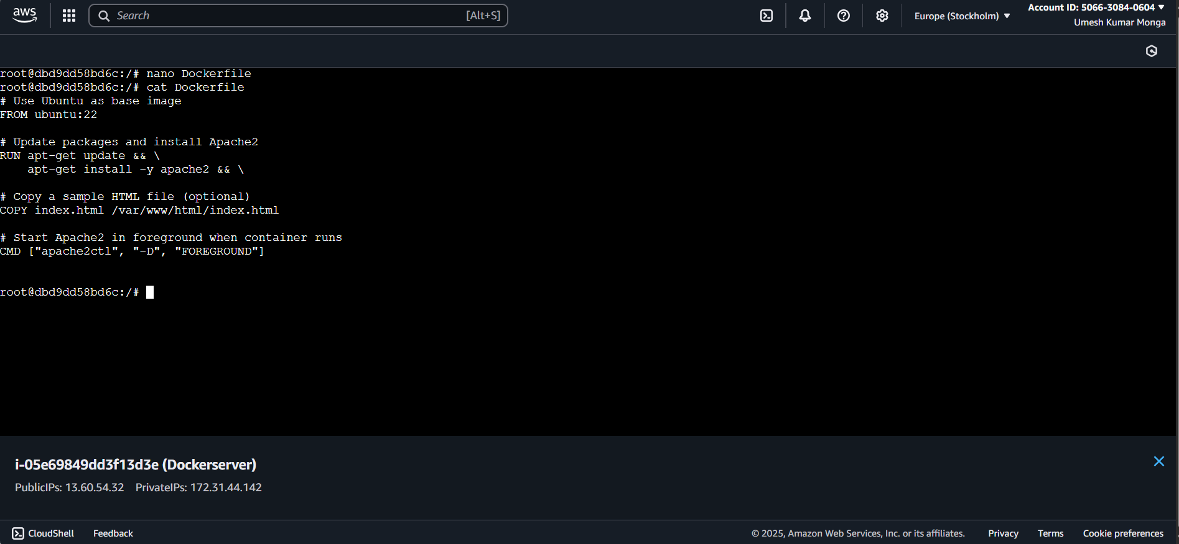

# Submit the Dockerfile for assignment completion

